ANALYSIS OF THE DETERMINANTS OF DIFFERENT LEVELS OF FINANCIAL INCLUSION IN DEVELOPING COUNTRIES

BA 639: An independent study project for partial fulfilment of the requirements of Master of Science (Business Analytics) program offered by Stetson School of Business and Economics, Mercer University.

By Anatou Khadidia SOUMAHORO

March 2019

Advisors

Myriam Quispe-Agnoli

Associate Professor of Economics

Dr. Vijaya Subrahmanyam

C. Ben Harnsberger Professor of Finance

INTRODUCTION

This study attempts to analyze different level of financial inclusion among the respondents of the Global Financial Inclusion database provided by the World Bank using the most recent survey results published in 2017 and covering results for 2014 and 2017. Most studies assume that an individual is financial included as soon as he has an account at any formal financial institution (bank, mobile account, …). However, we believe that financial inclusion should go beyond the simple access to financial services and cover the actual use of those services and the level of interaction an individual has after the opening of the account. In that sense, we decided to include the fact that an individual in addition to having a bank account, has a debit and credit card at first. Secondly, we added the fact the individual interacts with the financial system by making deposits and withdrawals to this account. Lastly, we analyzed a third level for an individual who has an account, if he also made transactions such as deposits and withdrawals. The second and third level have an emphasis on the minimum transactions an individual should have after opening a bank account. Our analysis was based on 58 countries considered as low and lower -middle income according to World Bank. We decided to study these countries because according to the world bank 75% of people without bank account lives with less than 2$ per day and are considered as “the poor” (Global Findex, 2018).

Financial inclusion means access to and usage of appropriate, affordable and accessible financial services (Elnaggar, 2018). Financial access eases daily life, and helps families and businesses plan for everything from long-term goals to unexpected emergencies. When financial included, population with low income are more likely to use services, such as credit and insurance, to start and expand businesses, invest in education or health, manage risk, and face financial shocks, which can improve the overall quality of their lives. Determining ways to improve financial inclusion for underserved population is a way to give them access to some financial security hence improve their quality of life and participate in the fight against poverty in the world.

We based our research primarily on the Global Findex database provided by the World bank. The Global Findex database covers more than 200 indicators about topics such as account ownership, payments, saving, credit, and ability to address financial emergency. The indicators are constructed with survey data from interviews with more than 150,000 respondents randomly selected adults age 15 and above in those 148 economies (World Bank, 2018). The survey was produced in 2011, 2014 and 2017 Four our analysis we used results from 2014 and 2017 because they provided the most insights on the questions we wanted to cover. In addition to the FINDEX database, we used variables from the 2019 Index of Economic Freedom and Financial Development Index to add some country-level characteristics to the respondents’ profile and analyze how they influence the level of financial inclusion of an individual. Some countries have put in place programs and strategies in order to promote financial inclusion. Such programs are called a National Financial Inclusion Strategy (NFIS). Therefore, we included a variable that access the fact that a respondent was from a country to analyze the impact that such program has on the financial inclusion level of an individual and if it was positive marker or not.

We run linear regression models and find out the main determinants of financial inclusion despite the different levels were receiving payments from the government, employment status and education level. We also found that the National Financial Inclusion Strategy estimator was not significant to assume that it was a determinant of Financial inclusion. When we take a look at financial level with emphasis on transactions (Deposit and withdrawals), the estimator relative to the value of digital money transactions was more significant than the estimator relative to bank branches and ATMs. We can therefore conclude that digital transactions are better determinants of financial inclusion compared to physical transactions.

LITTERATURE REVIEW

Researchers have addressed the topic of financial inclusion by covering different aspect of the question. Most of the papers we found used prior version of the Findex database (2014 or 2011). Asli Demirguc-Kunt, Leora Klapper and Dorothe Singer are Economist in the Finance and Private Sector Research Team of the Development Research Group at the World Bank. They produced a paper using the Worlds bank’ Women, Business and the law Database, the measures of gender norms from the OECD’s Gender, Institutions and Development (GID) database added to the Global FINDEX (2011) and analyzed the gender differences in the use of financial services. They found out using Multivariate regression analysis and Probit models that even by controlling demographic characteristics such as income, education, employment status, rural residence and age, the difference between men and women was still remarkable. They also discovered that legal discrimination against women and gender norms may explain some of these variations. Hence, women from countries where female had legal restriction regarding employment, right to inheritance per example were less likely to use simple services such as borrowing or saving through formal institution (Demirguc-Kunt, A., L. Klapper, and D. Singer. 2013.). Looking at the question on amore geographic way, Eric Asarea, Gertrude Nakakeetob, Seggara Eduardoc former PhD candidates at Texas tech University analyzed with a Multinomial Probit model, the Determinants of the choice of a savings option in African households using the 2014 Global Findex database. This study is particularly interesting as a put an accent on formal vs informal banking services. Informal would be mobile money services primarily. An interesting finding was that female entrepreneurs were more favorable in using informal type of banking compared to male. Another finding was that Individuals from East Africa are more incline to have more mobile accounts and this was confirmed in our results where Kenya was always in the top three country with the highest level of financial inclusion and had the highest among African countries (Asare, E., Nakakeeto, G., & Eduardo, S., 2018). Still focusing on Africa, Issouf SOUMARÉ, Fulbert TCHANA TCHANA and Thierry Martial KENGNE made an analysis of the determinants of Financial Inclusion in Central and West Africa two of the least financial inclusive regions of the Africa continent based on the 2011 version of the Findex database published recently by the World Bank. Using cluster specific fixed effect model (CSFE) as well as a logit/ probit regression, the main finding was that educated, working-age, urban resident and full-time employed individuals had greater chance to have an account at a formal financial institution in the stated regions. (SOUMARE, I., TCHANA TCHANA, F., & KENGNE, T., 2019).

DATA SOURCES & DICTIONARY

Our analysis will be mainly based on the 2014 and 2017 FINDEX survey (Micro data). We also took some variables from the 2019 Index of Economic Freedom and most recent Financial Development Index produced by the World bank published in 2016. Additionally, we included a variable that access the fact that a respondent was from a country with a National Financial inclusion strategy. We also included the value of digital transaction (e_money) for each country from the Global Payments systems survey.

(Data Dictionary, appendix)

DATA REDUCTION

1. Removing missing variables

We started the data cleaning by analyzing the amount of missing values in the both Findex databases (2014 and 2017) separately. Fortunately, we roughly had less than 5% of missing values among our demographic variables (gender, age, employment, education level). We proceed and deleted any records that has a missing value or a “did not answer” as response.

1. Formatting variables

The response to the survey questions included answers “Refused to answer” and “Do not know”. We decided to consider these two as a “No” answer to the question. We then proceed to turn all responses to the survey question to 0 (answered No to the question) and 1 (answered Yes to the question).

1. Additional variables

Additionally, to the individual level data from the FINDEX databases, we included some country-level data.

We found a list of countries on the World Bank website with National Financial Inclusion. We created a variable *NFIS* with Value 1 if the respondent was from a country with such program and 0 if the respondent is not.

In order to assess the access to financial institution and their ability to make transactions (Withdrawal and deposit) of the respondent, we included three variables: the number of Bank branches per 100,000 adults (*Bank_Access*) , ATMs per 100,000 adults (*ATM_Access*) and the value of digital transactions in the country per GDP ( *E_money*) for each respondent country.

The notion of Financial inclusion includes also the accessibility to insurance to face disaster creating financial hardship and therefore the access to insurance. Hence, we included the Life + Non Life insurance premium volume to GDP according the respondent’s country (*Ins_Cov)*

After cleaning every data set separately, we then proceeded to join them. Our final dataset covers 58 countries and 18 variables.

DATA EXPLORATION

1. Plots of variables

* Age distribution

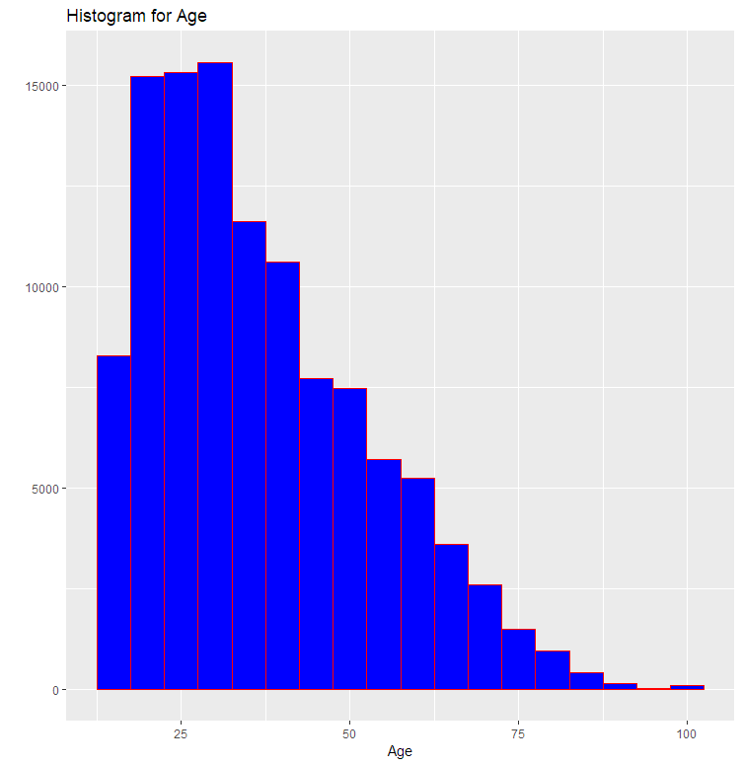

The age distribution is skewed to left. 61% of respondents are less than 35 years. The minimum age is 15.

The age^2 variable has been added to take in account the different relationship people have with the financial system depending of their age. Per example, 30 years old will probably has more necessity to have a bank account than a typical 15 years old.

* Gender

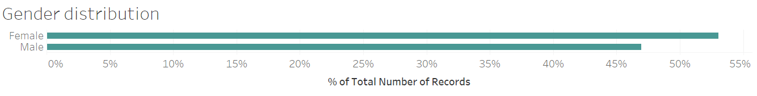

Our dataset contains 47% of Male respondents for 53% for female. We can say that the gender ratio is fairly leveled.

* Geography

The analysis covers 58 countries around the world. We focused on the low and lower- middle income according to the World Bank. This heat map represents the average number of respondents to the FINDEX survey who has an account at financial institution. We can see that the top five countries with the highest level of inclusion are Mongolia, India, Kenya, Ukraine and Nigeria

*Note: For the current 2019 fiscal year, low-income economies are defined as those with a GNI per capita, calculated using the World Bank Atlas method, of $995 or less in 2017; lower middle-income economies are those with a GNI per capita between $996 and $3,895 (World Bank, 2019)*

*The****GNI per capita****is the dollar value of a country's final income in a year, divided by its population. It reflects the average income of a country's citizens (World bank, 2019).*

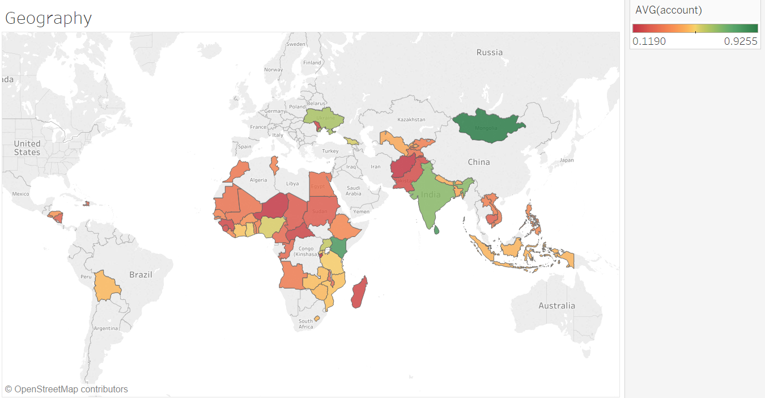

* Financial inclusion level
  + Financial inclusion Basic Level

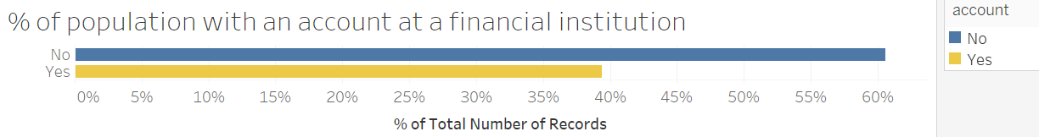

The level of financial inclusion is usually determined by the percentage of population having an account at any formal financial institution (banks, mobile account, …). Only 39% of our respondents have an account.

In addition to having a bank account, we decided to analyze in more depth the relationship respondents have with the financial system by taking in account the fact of having (1) a debit card, (2) a credit card, (3) done a deposit in an account in the past 12 months and (4) done a withdrawal in the past 12 months. We then created additional variables based on these parameters.

The basic level of inclusion is the fact of having a bank account (variable *account)*

* + Financial inclusion Level 1

We created a variable *FI_level1* representing the fact that an individual has additionally to an account, a debit card and a credit card

**FI_level 1 = average (account + debit + credit)**

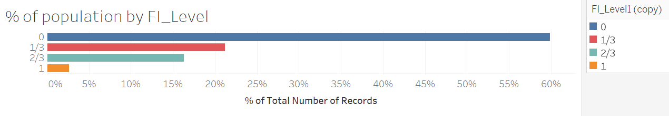

* + Financial inclusion Level 2

We created a variable *FI_level2* representing the fact that an individual additionally to an account, has a debit card, a credit card, done a deposit and a withdrawal in the past 12 months

**FI_level 2 = average (account + debit + credit +deposit + withdraw)**

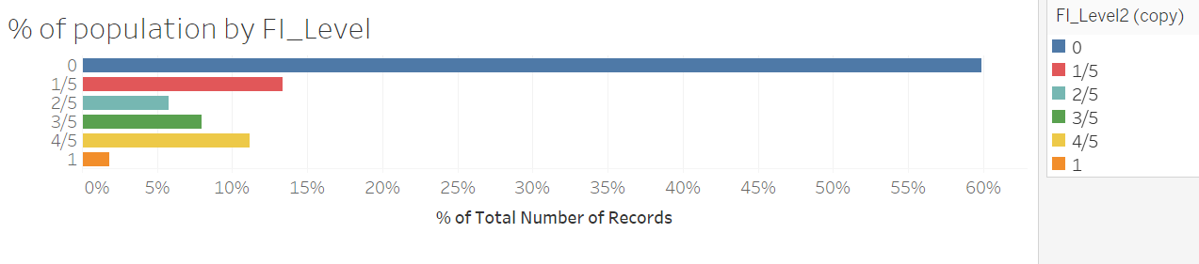

* + Financial inclusion Level 3

We created a variable *FI_level3* representing the fact that an individual additionally to an account, has done a deposit and a withdrawal in the past 12 months

**FI_level 3 = average (account + deposit + withdraw)**

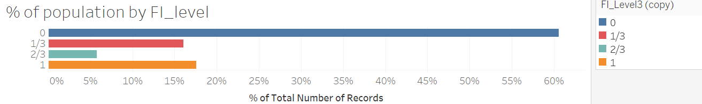

* National financial inclusion strategy (NFIS)

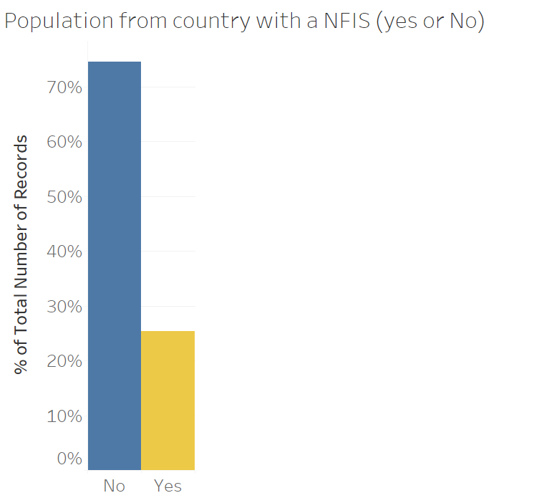

25% of our respondents are coming from countries with NFIS.

* Comparison of the level of financial inclusion per countries

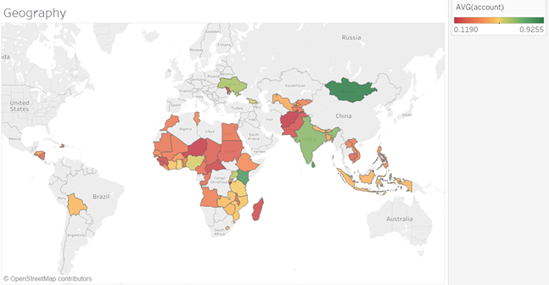

The top 3 countries for account ownership: Mongolia (92% of population) , India (67%) and Kenya (81% of population). We have the same results with very small variations when we change the level of inclusion and included transactions and having debit and credit cards.

* Government payment vs Financial inclusion level

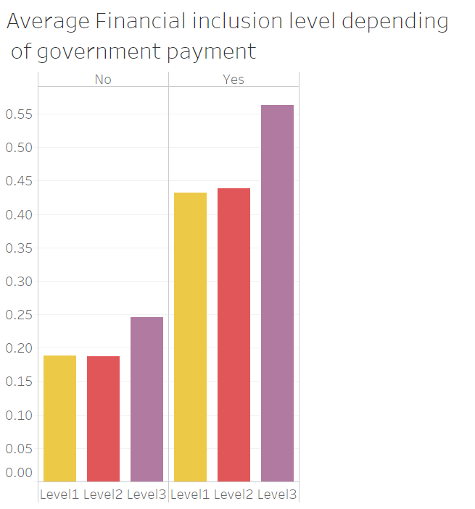  
Receiving payments from the Government, almost double the chance of an individual being financial included regardless of the level of interaction with the financial system. As we can see somebody do not receive any remittances from the government he would score 19% at our level 1 of inclusion and 25% for the level 3. If someone does receive money from the government, this goes to 44% and 56% respectively.

* Employment status vs Financial inclusion level

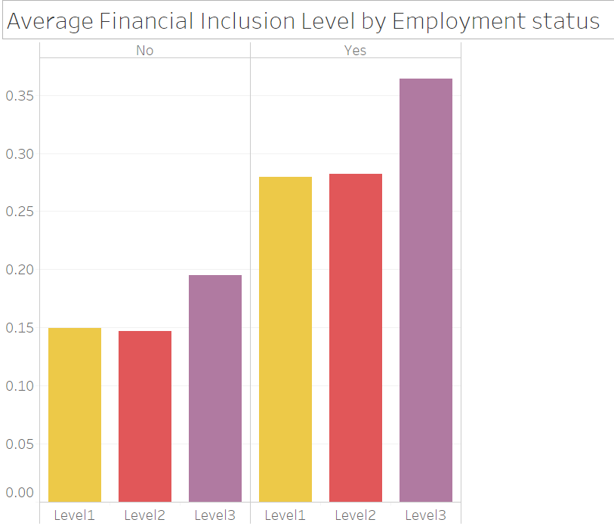

Being employed, almost double the chance of an individual being financial included regardless of the level of interaction with the financial system.

* Evolution of financial inclusion level depending of the year

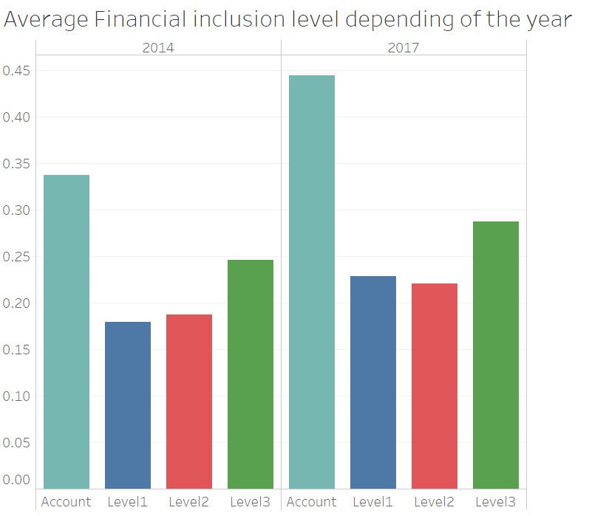

It appears that all levels of financial inclusion somehow improve from 2014 to 2017. The number of account drastically improved compared to levels including transactions.

1. Descriptive statistics

We have a total of 112062 observations and no missing values for all variables.

After adding the third level of Financial inclusion, here is the descriptive statistics

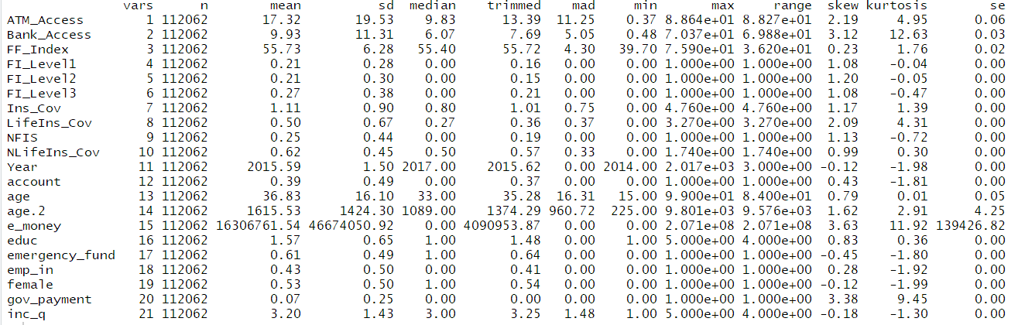

E_Money has very high values compared to all the over country level data Hence, use decided to use Log (e_money) for our models

1. Correlation Matrix

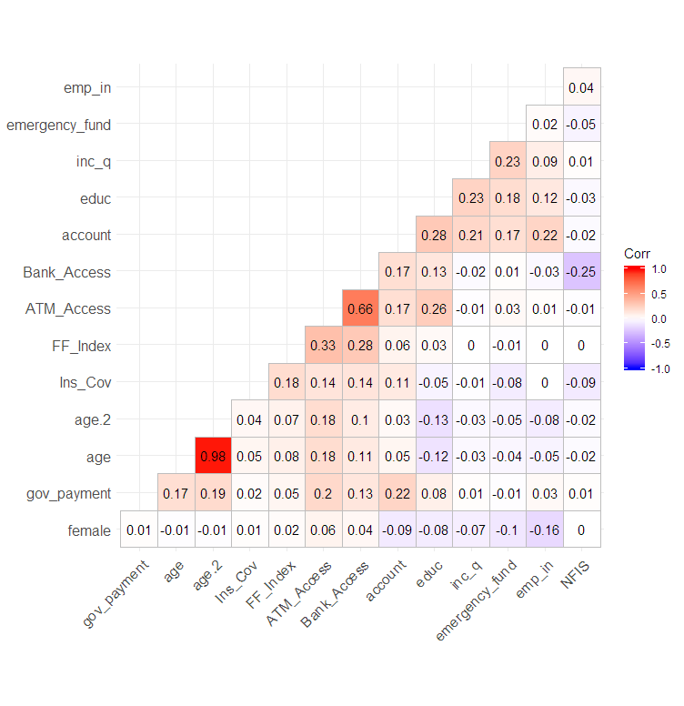 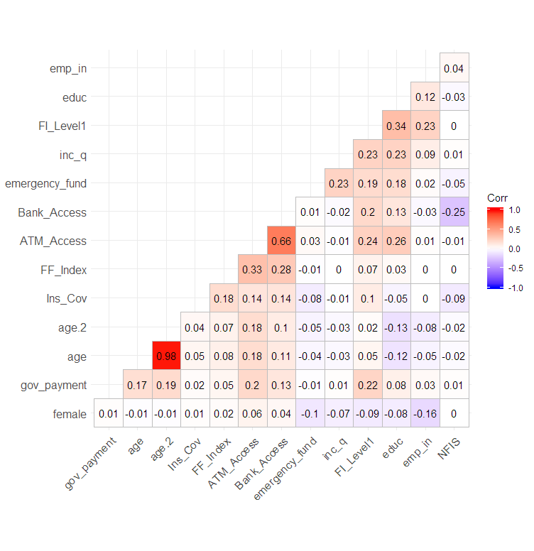

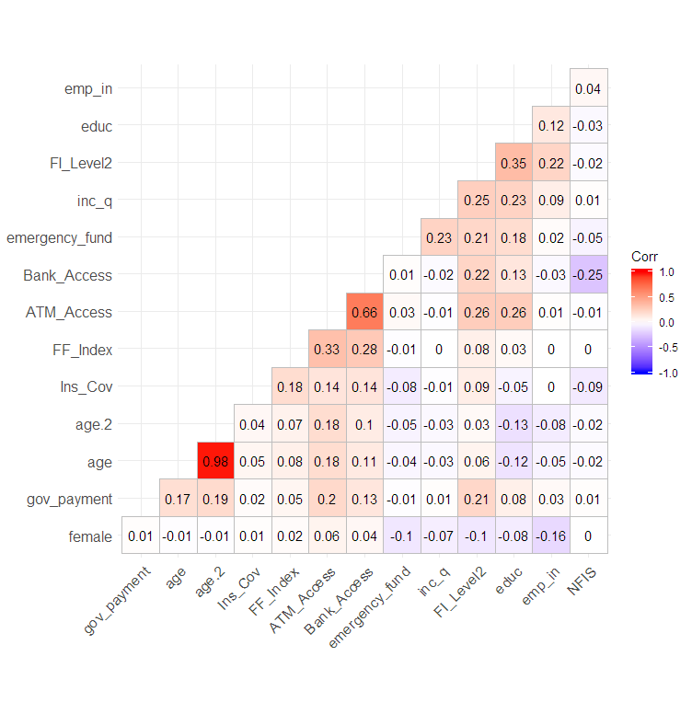 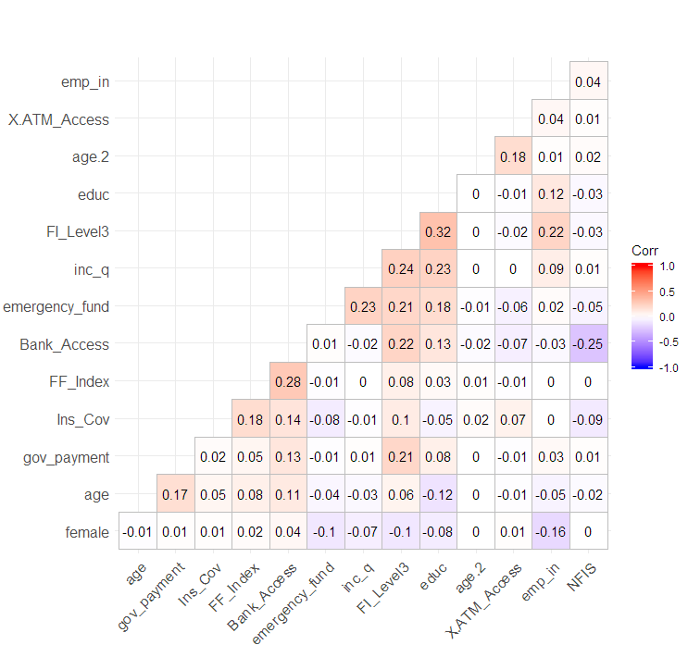

* The strong positive correlation between ATM_Access and Bank_Access is understandable. Both variables assess customers access to banking.
* All the over variables have a weak correlation (less than 0.39)

Here is a scatterplot of ATM_Access and Bank_Access A close up of a map

Description generated with very high confidence

*P value < 0.05,* the correlation between these variables is significant

We have a linear correlation between ATM_Access and Bank_Access. We do have 2 strong outliers but with the number observation we have , we decided to keep them for the analysis in the first step and then remove one of them

* Age and Age^2

The age^2 variable has been added to take in account the different relationship people have with the financial system depending of their age. Per example, 30 years old will probably has more necessity to have a bank account than a typical 15 years old.

METHOODOLOGY & RESULTS

We ran LINEAR REGRESSIONS for each level of financial inclusion we previously defined to compare how the different estimates were changing compared to the others depending of the definition. We decided to use this technic because our dataset showed small correlation among variables. Also checking at the kurtosis and skewedness, most of our variables had small values except for E_money where we used the logarithm to attenuate the effect and also ATM_access, which we removed further in our analysis. Also, since we want to compare how each variable impact each level of inclusion we previously defined, the linear regression seems appropriate as our base for comparison, no focusing on the actual value of the coefficient.

We primarily these regression without the E_Money variables because this variable had information for a limited number of countries (22 countries over 58 in total)

1. Regression without Digital money information

|  |  |  |  |  |  |  |  |  |
| --- | --- | --- | --- | --- | --- | --- | --- | --- |
|  | Account |  | FI Level 1 |  | FI Level 2 |  | FI Level 3 |  |
|  |  | sign 0 '***' |  | sign 0 '***' |  | sign 0 '***' |  | sign 0 '***' |
| female | -3.43E-02 | *** | -2.19E-02 | *** | -2.48E-02 | *** | -3.02E-02 | *** |
| age | 1.11E-02 | *** | 6.97E-03 | *** | 7.74E-03 | *** | 9.65E-03 | *** |
| age.2 | -1.14E-04 | *** | -7.30E-05 | *** | -7.88E-05 | *** | -9.60E-05 | *** |
| inc_q | 4.18E-02 | *** | 2.73E-02 | *** | 3.18E-02 | *** | 3.94E-02 | *** |
| emp_in | **1.67E-01** | *** | **9.36E-02** | *** | **9.65E-02** | *** | **1.24E-01** | *** |
| educ | **1.45E-01** | *** | **1.02E-01** | *** | **1.08E-01** | *** | **1.29E-01** | *** |
| emergency_fund | 1.07E-01 | *** | 6.32E-02 | *** | 7.94E-02 | *** | 1.05E-01 | *** |
| gov_payment | **3.60E-01** | *** | **1.86E-01** | *** | **1.85E-01** | *** | **2.44E-01** | *** |
| FF_Index | -3.73E-04 | *** | -9.59E-04 | *** | -6.18E-04 | *** | -5.72E-05 |  |
| Ins_Cov | 6.27E-02 | *** | 3.19E-02 | *** | 2.96E-02 | *** | 3.92E-02 | *** |
| ATM_Access | -7.82E-04 | *** | 1.04E-03 | *** | 9.76E-04 | *** | -2.45E-04 | *** |
| Bank_Access | 5.82E-03 | *** | 2.46E-03 | *** | 3.41E-03 | *** | 5.46E-03 | *** |
| NFIS | 3.30E-02 | *** | 2.43E-02 | *** | 2.18E-02 | *** | 2.52E-02 | *** |

**Key Findings**

The estimates are consistent among the variables. We considered a 0.0001 Level of significance

* The strongest estimators remain Employment, education and receiving government remittances.
* When Financial inclusion is defined is defined as having only an account, being a female is a positive indicator. However, when including transactions and interaction, being a female becomes a negative factor
* Something interesting is that at the level 3 which measure (account+ deposit + transaction), the ATM_access coefficient is negative. One would think that the access to ATMs should drive the level of transactions, but this is not the case here.
* The Financial freedom index is not significant at the level 3 as well, meaning that we cannot argue that the level of financial freedom of a country has any effect on the level of transaction (deposit + withdrawal) specifically
* The coefficient for the access to an emergency fund is almost the same for our basic level of financial inclusion (having an account) and the level 3. We found the same results in the second set of regression analysis. This could mean that an individual with access to an emergency fund who has a bank account will probably make withdrawal and deposit and assess a higher level of inclusion.

1. Regression with Digital money information

Based on the prior regression we ran, we decided to take out the ATM_Access variable as well the financial freedom index variable and to add the E-Money variable. In order to minimize the effect of outliers with the E_money variables we use the Log of the value.

|  |  |  |  |  |  |  |  |  |
| --- | --- | --- | --- | --- | --- | --- | --- | --- |
|  | Account |  | FI Level 1 |  | FI Level 2 |  | FI Level 3 |  |
|  |  | sign 0 '***' |  | sign 0 '***' |  | sign 0 '***' |  | sign 0 '***' |
| Female | 2.60E-02 | *** | -1.91E-02 | *** | -1.95E-02 | *** | -2.21E-02 | *** |
| Year | 1.50E-02 | *** | 5.28E-03 | *** | -4.14E-04 |  | -9.58E-04 |  |
| age | 1.02E-02 | *** | 6.36E-03 | *** | 6.92E-03 | *** | 8.55E-03 | *** |
| age^2 | -1.01E-04 | *** | -6.36E-05 | *** | -6.64E-05 | *** | -8.08E-05 | *** |
| income level | 4.68E-02 | *** | 3.32E-02 | *** | 3.89E-02 | *** | 4.72E-02 | *** |
| employment (Yes) | **1.45E-01** | *** | **9.01E-02** | *** | **1.07E-01** | *** | **1.37E-01** | *** |
| Education level | **1.33E-01** | *** | **1.13E-01** | *** | **1.20E-01** | *** | **1.31E-01** | *** |
| Emergency fund | 1.17E-01 | *** | 7.11E-02 | *** | 8.94E-02 | *** | 1.17E-01 | *** |
| Government payment | **3.08E-01** | *** | **1.62E-01** | *** | **1.77E-01** | *** | **2.35E-01** | *** |
| Insurance premiums volume | 4.70E-02 | *** | 2.20E-02 | *** | 1.75E-02 | *** | 2.28E-02 | *** |
| Bank branches | 2.34E-03 | *** | 2.56E-03 | *** | 2.99E-03 | *** | 3.20E-03 | *** |
| Log (e_money) | 4.17E-02 | *** | 1.80E-02 | *** | 1.63E-02 | *** | 2.30E-02 | *** |

**Key Findings**

* We found that log(E_Money) has strong coefficient in every level of financial inclusion and the coefficient is stronger for the level 3 where the person has an account and makes transactions.
* E_Money coefficients are always higher than the bank branches coefficients meaning that digital finance availability has more impact on having an individual financial included compared to the availability of bank branches
* The coefficient for age^2 is negative in every level of financial inclusion meaning that as people get older the effect of age is reduced

CONCLUSION & RECOMMENDATIONS

The main determinants of financial inclusion remain stable despite the level of inclusion we analyzed being receiving remittances and payment from the government, the employment status and education level. These results let us understand that increasing access to fair employment and education would greatly improve both account ownership and the level of interaction with the financial system. Aligning with articles we reviewed addressing gender inequality, we also found out that female has less chance of being financial included and even when they were included, they would have a lower level of interaction with the financial system compared to males. Governments and policy makers should develop strategies towards fostering financial inclusion for women and create opportunities to increase their level of interaction after they open an account. Additionally, we found out that digital transaction was a greater determinant of financial inclusion compared to physical branches. This understandable by looking at the convenience of being able to make transaction without having to travel and represents a business opportunity for Fintech companies. Indeed, technological companies proposing financial services usually called Fintech usually provide free or low-cost transactions fees services and could definitely help improve financial inclusion and surely increases transaction level. Governments Adapt Legislations and policies to attract. Fintech companies and startups. On another side traditional banks who usually operates through physical branches could attract more customers by also providing digital transactions and therefore be more competitive.

Furthermore, it will be interesting to further analyze the impact of the Mobile Money services specifically on the level of financial inclusion. Mobile Money is a service offered by Telecommunication services that allows to make transactions only thru the cellphone. This service is widely used in Asia and Africa where most the countries we analyze in this paper are. The lack of available open data on the subject limited our ability to assess the question but hopefully some data will be available for research in a near future.

REFERENCES

Elnaggar, D. (2018, October 02). Financial Inclusion, Overview. Retrieved February 24, 2019, from <https://www.worldbank.org/en/topic/financialinclusion/overview>

World Bank. (2018). Home | Global Findex. Retrieved February 24, 2019, from <https://globalfindex.worldbank.org/#data_sec_focus>

Demirguc-Kunt, A., L. Klapper, and D. Singer. 2013. “Financial Inclusion and Legal Discrimination against Women: Evidence from Developing Countries.” Policy Research Working Paper 6416, World Bank, Washington, DC.

Asare, E., Nakakeeto, G., & Eduardo, S. (2018, February). Determinants of the choice of a savings option: “The case of African Households”. Retrieved February 24, 2019 from https://ageconsearch.umn.edu/record/266868/files/Determinants of the choice of a savings option SAEA Paper.pdf

Texas Tech University, Department of Agricultural and Applied Economics, Agricultural Science

SOUMARE, I., TCHANA TCHANA, F., & KENGNE, T. (2019, January). Analysis of the Determinants of Financial Inclusion in Central and West Africa. Retrieved February/March, 2019, from https://openknowledge.worldbank.org/bitstream/handle/10986/26005/10.108019186444.2016.1265763.pdf?sequence=1&isAllowed=y

APPENDIX

